**The Ruqyah Journey  
Start your Ruqyah and Higher Ruqyah journey in the 1st stage and learn more complex techniques as you progress.**

**Director**

**Steer**

Strategise international expansion of Higher Ruqyah

**Higher Ruqyah:**

Firesheets

**Associate**

**Practitioner**

**Specialise**

12 months - £1200

Develop new ruqyah techniques that impacts the medical world

**Higher Ruqyah:**

Tea of Dissolution

**Serve**

6 months - £1200

Start practising professionally and earning a side-income

**Higher Ruqyah:**

10 second Black Seed Oil

**Apprentice**

**Start**

6 months - £600

Be able to practice on family and friends

**Higher Ruqyah:**

10 second Water 10 second Apple Cider Vinegar

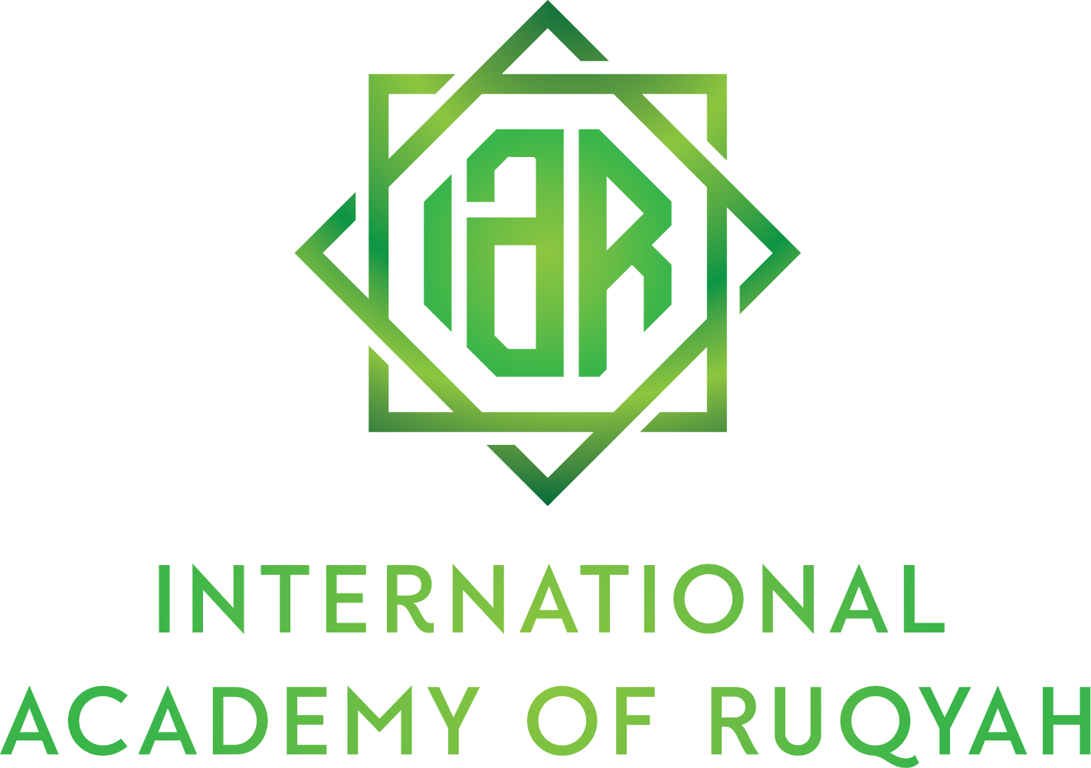

**STAGE 1: Start [Ruqyah Apprentice]  
Start practising Level 1 and Level 2 ruqyah straight away and be able to be do Higher Ruqyah in 10 seconds!**

•

L = Lesson

F = Feedback

P = Practical

C = Cleansing

I = Intro Next Stage

**ENTRY REQUIREMENTS:** 18+ years old, read the core text book ‘Mastering Islamic Exorcism’ and successful application.  
**COURSE FEE:** £100 per 4 weeks (x6); or £500 upfront.

The Apprentice stage allows you to start practising ruqyah from the first day of the programme. The weekly feedback calls give valuable opportunity to discuss the cases you’re working on to ensure that ongoing support is provided so your questions are directly related to current real-life situations you’re facing.

The 4-weekly practical session is an in-person opportunity for you to bring your cases (or practice on other participants) so crucial practical feedback can be provided and ruqyah skills can be sharpened under supervision. Also incorporated is spiritual analysis and spiritual cleansing to remove backlash you’ve picked up, and in later sessions, to allow for enhancements in efficacy.

An exclusive taste of Higher Ruqyah is taught that will begin your journey of doing effective ruqyah in less than 10 seconds!

L1

L2

L3

L4

L5

L6

I1

Core Verses  
Common Ruqyah Practices

Start Practising!

Hands of Ruqyah

Detecting Evil in Body (Basic)

Possession Handling

Ruqyah Combinations

How to Make Ruqyah Water in 10 seconds

How to Make Ruqyah ACV in 10 seconds

Closing and Intro to Practitioner Stage

F

F

PCF

F

F

PCF

F

F

PCF

F

F

PCF

F

F

PCF

F

F

PCF

L = Lesson

F = Feedback

P = Practical

C = Cleansing

I = Intro Next Stage

**ENTRY REQUIREMENTS:** Completion of Stage 1 and successful application to progress to Stage 2.  
**COURSE FEES:** £200 per 4 weeks (x6); or £1000 upfront.

The Practitioner stage is where you start offering your services to the public professionally and can start receiving an income. The weekly feedback sessions are also used to cleanse backlash picked up due to an increase in ruqyah activity. Monthly practical sessions still remain intact to ensure you’re still progressing your ruqyah skills to keep increasing efficacy.

A focus on kick-starting the development of your spiritual senses and also interpreting them accurately will give you the correct foundation to analyse your clients’ situations with a high level of accuracy so that you can apply the correct ruqyah technique for differing spiritual situations, and begin to benchmark spiritual progress using spiritual senses.

L7

L8

L90

L10

L11

L12

I2

Building your Business

How to Make Ruqyah Black Seed Oil in 10 seconds

Herbal Impact

Visual Ruqyah

Excelling in Inspiration and Intuition

Triangular Analysis

Closing and Intro to Associate Stage

FC

FC

PCF

PCF

PCF

PCF

PCF

PCF

FC

FC

FC

FC

FC

FC

FC

FC

FC

FC

**STAGE 2: Serve [Ruqyah Practitioner]  
Start earning, intense spiritual cleansing for increased ruqyah efficacy, and minimise risk of incorrect analysis.**

R1

R2

R3

R7

R9

R11

R13

Concept

Project Design

Project Plan

Pilot Testing

Pilot Testing

Pilot Testing

Wider Test Plan

Wider Testing

Wider Testing

Wider Testing

Wider Testing

Wider Testing

Conclude

R4

R5

R6

R8

R10

R12

**STAGE 3: Specialise [Ruqyah Associate]**  
**Identify and prove treating an ailment conventionally can be enhanced via Higher Ruqyah and change the perception of medicine forever!**

**ENTRY REQUIREMENTS:** Completed stage 2, demonstrated desire to develop new ruqyah techniques and successful application.  
**COURSE FEES:** £100 per month.

The Ruqyah Associate owns the development of treatment techniques specific to an agreed ailment with close guidance from the IAR Directors. This includes enhancing previously taught techniques to improve efficacy, being taught the latest Higher Ruqyah techniques as of when required, assistance in developing new Higher Ruqyah techniques and regular spiritual cleansing to improve ability and efficacy.

The objective of the Ruqyah Associate is to contribute to making permanent progress in the field of ruqyah that will benefit future generations.

Monthly review sessions are put into place to ensure continuous progress. Weekly sessions will cover any necessary feedback, revision of previous concepts, continuous improvement of skills and spiritual cleansing as of when required.

R = Review

**STAGE 4: Steer** **[Ruqyah Director]**  
**Pro-actively expand the practise of Higher Ruqyah internationally!**

**ENTRY REQUIREMENTS:** Completed stage 3, developed new ruqyah techniques, demonstrated ability to develop others, and successful application.

The Ruqyah Director becomes a core member of the Higher Ruqyah strategic steering committee which works to expand the use of Higher Ruqyah through the world by pro-actively seeking and exploiting opportunities for growth.

